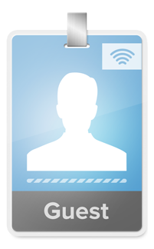

Wi Fi Information

**Joining the network is simple**

*(This applies to each device)*

1. Select the open "TrioTownHomes" wifi SSID on your wifi enabled device.

2. Open a web browser. (A login page should open automatically.)

3. Login using the credentials on this brochure

4. Using standard browser settings, you should only have to log in a single time. Our system is designed remember your device the next time you use the network.

**You DO NOT have to stay on the login page**

TRIO Townhomes & Apartments

4843 Pierce St Suite A, Allendale, MI 49401

Phone: (616) 466-7844

www.yourtrio.com/

Guests using the Trio Homes’ network will be asked to provide contact information. They will be assigned a generous 1 GB data cap and default bandwidth of 10 Mbps.

If they exceed their data cap, the account's bandwidth will be throttled back - easily allowing e-mails and texts - but limiting other activities.

Guests can login to their accounts as well. From their account profiles they can provide a credit card and pay one-time fee(s) for an additional gigabyte of data download and increased bandwidth. (This data expires after 30 days.

GUEST ACCESS

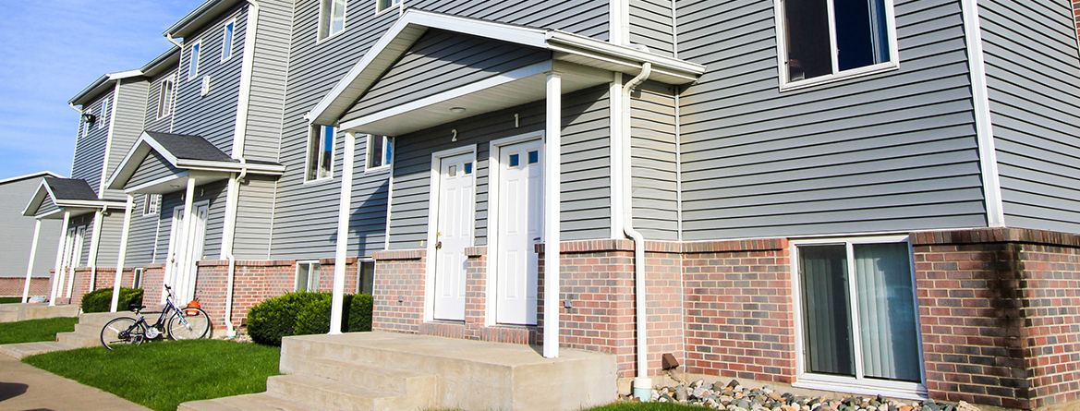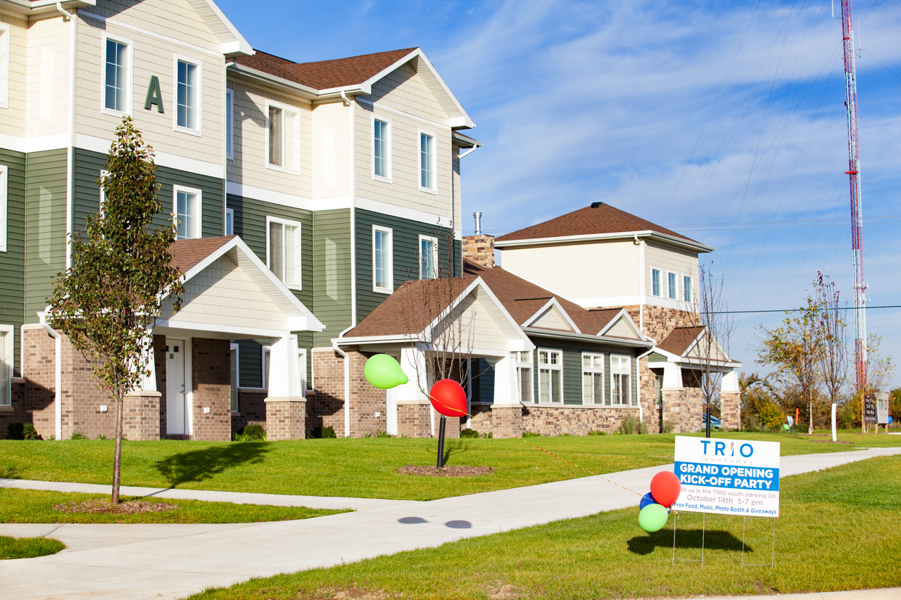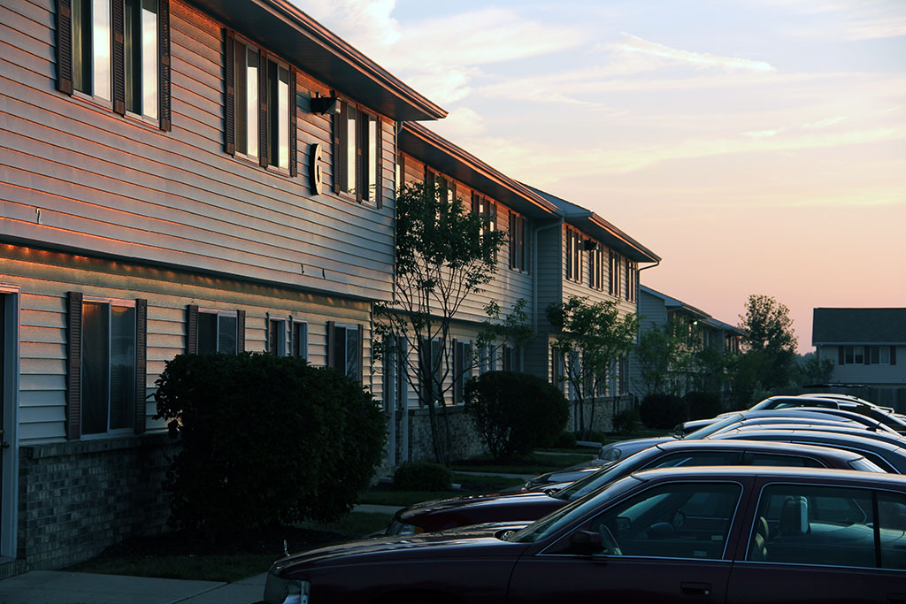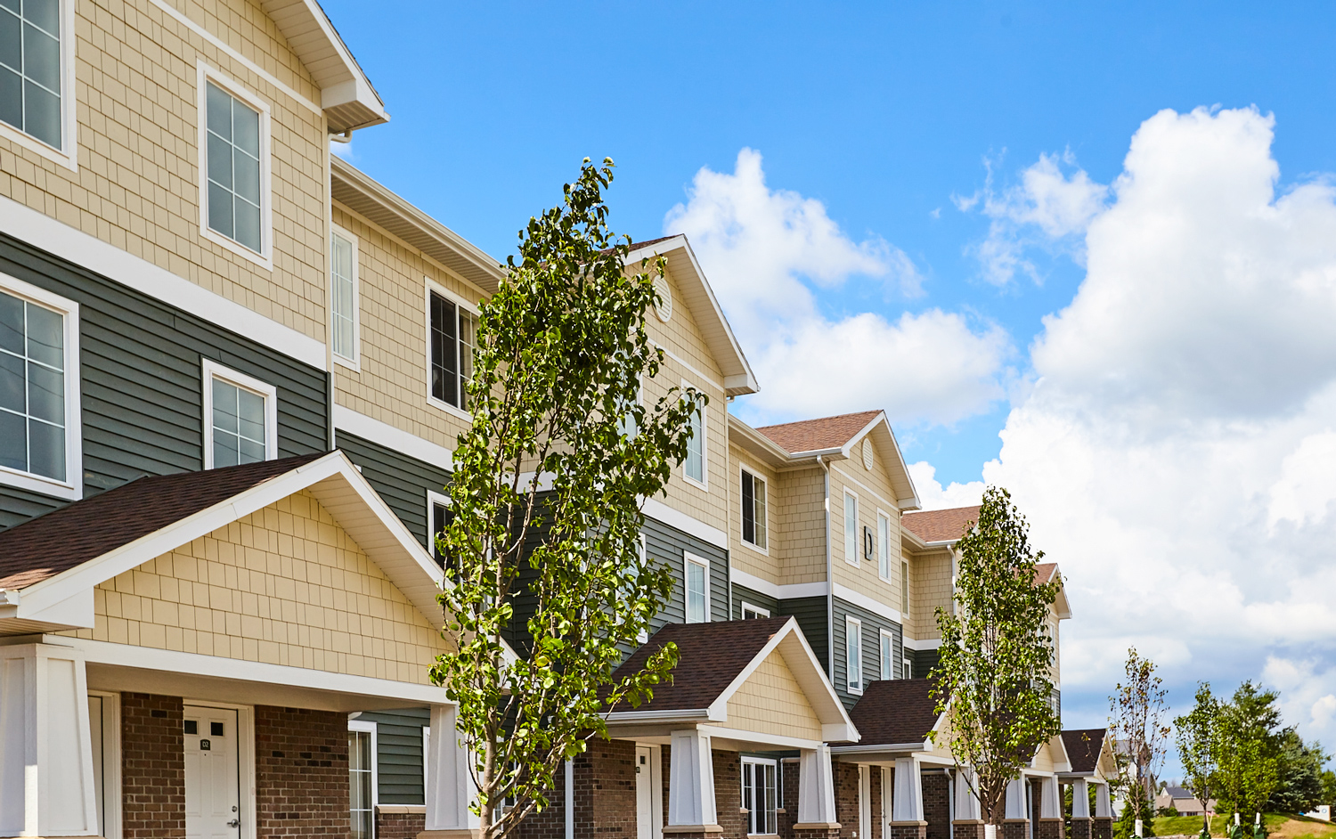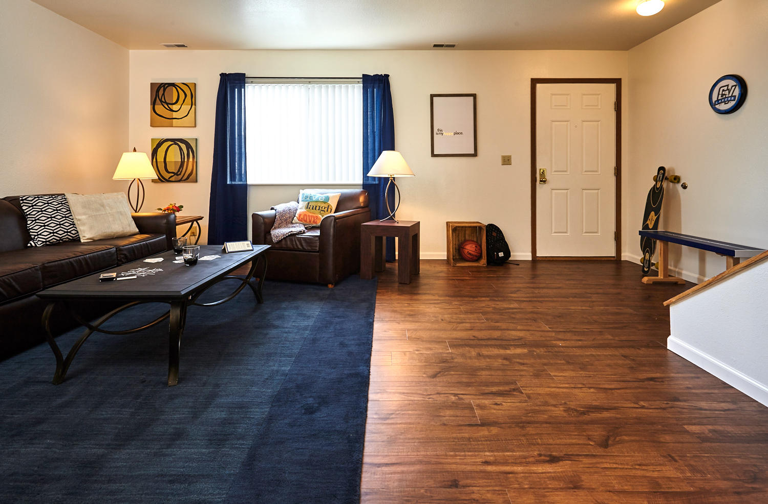

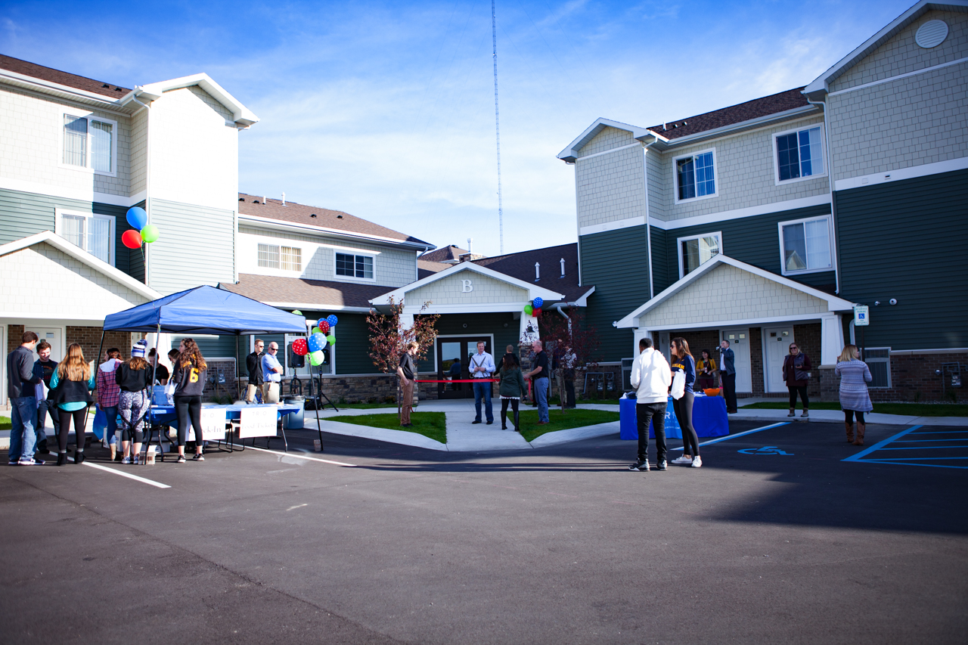

Thanks for picking up your Trio Townhomes Internet/WiFi Credentials!

The information included will allow you to access the Internet throughout all Trio apartments.

This access is included as part of your monthly rental contract.

Your credentials will allow you to have FIVE (laptop, desktop, tablet, smart phone, gaming system, etc.) devices use the Trio Townhomes network.

Each resident has their own individual account.

Enhancing your wifi experience

At any point, you can log into your Trio Townhomes user account by going to:

**http://access.yourtrio.com/portal/trio_portal**

and inputing your credentials.

Once in your account, you can access and review your current account settings.

TRIO RESIDENTIAL INTERNET: FREE

All Trio Townhome residents have a free internet account providing the following:

15 Mbps wifi access for up to 5 devices (with bursts up to 25Mbps)

This access is available throughout all Trio Homes facilities.

TRIO PREMIUM INTErnet: $15 per month

For an additional $15 per month - charged directly to your credit card each month, all of your devices will be allotted increased bandwidth.

30 Mbps wifi access for up to 5 devices (with bursts up to 40Mbps)

trio enhanced internet: $25 per month

For $25 per month - charged directly to your credit card each month, all of your devices will be allotted our maximum increased bandwidth.

50 Mbps wifi access for up to 5 devices (with bursts up to 70 Mbps)

Static IP Address are available. Contact the Office.

Custom network modifications can be made.

Hardline cabling is available.

Tech Support is available.

20 devices can be set up in most residences.

Additional settings & speeds can be accommodated.